Harmony Module

Harmony Module (Node 2) is a pressurized module which will serve as a connecting passage between the European Columbus laboratory, the US laboratory Destiny and the Japanese laboratory Kibo and cargo spacecraft at the International Space Station.

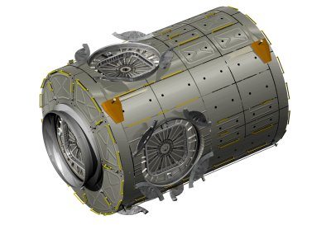

Node 2 also provides a docking port for the Space Shuttle and the Japanese HII transfer vehicle, whilst it also serves as an attachment point for the Multi-Purpose Logistics Modules (MPLM). Node 2 is designed to be a working base point for the Space Station robotic arm, Canadarm 2.

Harmony is a utility hub, providing air, electrical power, water and other systems essential to support life on the station. It distributes resources from the station’s truss to the Destiny lab and to the European Space Agency’s [Columbus Research Laboratory](http://www.aerospaceguide.net/iss/columbus.html) and the [Japanese Experiment Module (Kibo)](http://www.aerospaceguide.net/iss/kibo.html). In addition to increasing the living and working space inside the station, its exterior will also serve as a work platform for the station's robotic arm, Canadarm2. Harmony is similar in shape to the six sided Unity module, known also as Node 1, launched in 1998.

Harmony connecting module was delivered to the International Space Station inside Space Shuttle Discovery’s payload bay during Space Shuttle flight [STS-120](http://www.aerospaceguide.net/spaceshuttle/sts120.html) mission, also known as Assembly Flight 10A. STS120 was launched on October 23, 2007.

Harmony Module (Node 2) was developed for NASA under an ESA contract with European industry, with Alcatel-Alenia Space in Italy as the prime contractor. Responsibility for Node 2 development was assigned to the Italian space agency, ASI. The structural design is based on that of the MPLM and the European Columbus laboratory.

**Naming the Module**

NASA held a competition amongst schoolchildren in the United States to find a name for the Node 2 module. On 15 March 2007 the new name Harmony was announced. Node 2 received its name during an academic competition involving more than 2,200 students from 32 states.

Six different schools submitted "Harmony." A panel of NASA educators, engineers, scientists and senior agency management selected the name because it symbolizes the spirit of international cooperation embodied by the station, as well as the module's specific role in connecting the international partner modules.

The Node 2 Challenge required students to learn about the space station, build a scale model and write an essay explaining their proposed name for the module that will serve as a central hub for science labs. Harmony is the first U.S. piece of the space station named by people outside of NASA.

**Specs:**

**Length**: 7.2 meters (23.6 feet)

**Width**: 4.4 meters (14.5 feet)

**Mass**: 14,288 kilograms (31,500 pounds)

**Exterior**: aluminum cylindrical sections,

**Number of racks**: 8 Pressurized Volume: 75.5 cubic meters (2,666 cubic feet) Habitable Volume: 1,230 cubic feet

**Did you know?**

* Harmony (Node 2) is the first pressurized module added to the station since the Russian Pirs Docking Compartment was added in September 2001. Harmony joins three other named U.S. modules on the station: the Destiny laboratory, the Quest airlock and the Unity node.

* As of December 2007, the most recent U.S. pressurized module added to the International Space Station was the Quest airlock in July 2001.